Art styles
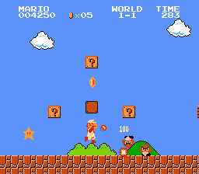
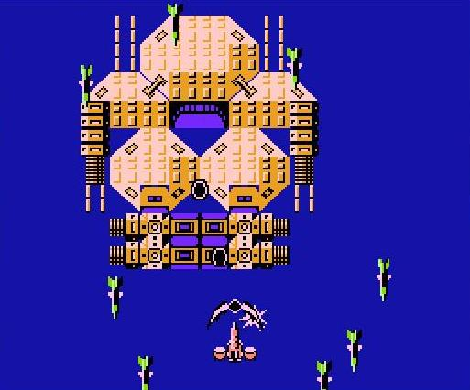
Since the art style will be pixilated, I have found a few examples
These two (Super Mario Bros and B wing) were both on the Nes and are '8 bit games', a referance to both the number of colours the machine could use and the system hardware. They benifit from being easy to draw, simple and have low processing power requirements (though with millions of possible colours being easily renderable nowardays this is no longer an issue). Downsides are that it can sometimes be hard to tell exactly what something is.

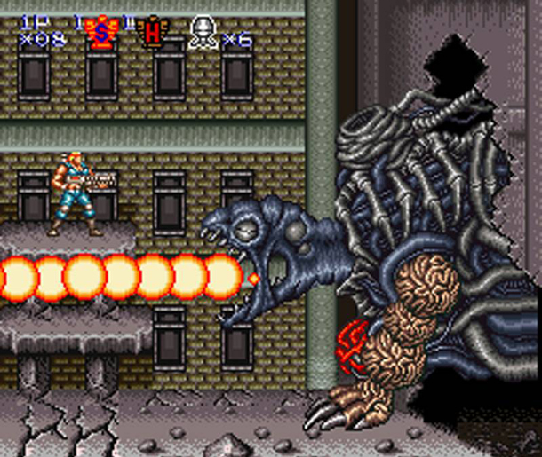
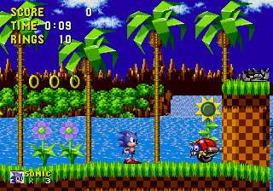
These two (Contra III and Sonic the Hedgehog) use newer 16 bit graphics. The big advantage to 16 bit graphics is that you can fit four pixels in the space of one 8 bit pixel, and you get a much larger selection of colours. I would suggest we use a similar style to this for our game, it offers enough room for detail, without taking the huge amount of time to create that anything of a higher definition would.

Colliders

One thing that could have been a problem for the project was the colliders for the water, more specifically that when spawned in large quantities that the water particles (small spheres) would collide with eachother, causing them to clip through eachother and fly off in the wrong direction. We have attempted to counter this with an idea I came up with, specifically having each particle spawn with a tiny hit-box that expands over a short period of time after firing. In our prototype build, this does indeed seem to work, though we have yet to test this in really large quantities.

Lag

Another issue with out method of simulating water is the amount of lag that it could cause. Testing seems to show it is at it's worst when a large amount of water has pooled up, and is suddenly moved. This can be assumed to be a result of every single collision box moving, and colliding with every other box. The drains at the bottom and limited water supply should counter or at least reduce this, ensuring the water cannot pool up enough to cause significant issues.

